In this challenge, you are going to simulate an incompressible-laminar-viscous flow through the backward facing step geometry. You should perform a transient simulation. The solver can be chosen based on the described physics of the flow. You need to explain the entire simulation procedure (how you set up the case). You should also provide explanations to every change you make inside the reference case files obtained from OpenFOAM tutorials. You can choose the inlet velocity shuch that the flow is laminar.
After that, you will perform 2 case studies as described below and compare the results.
Case 1 - Simulate the flow without using any grading factor (i.e., GF = 1)
Case 2 - Simulate the flow with grading factor of 0.2. The cells should be finer near the walls (includig the step wall).
You can use the following mesh parameters but you can feel free to modify these values.
Mesh specification
- Number of cells along the x direction (longer dimension) = 200
- Number of cells along the longer y direction = 20;
Boundary condition specification
The domain specifications are provided in the following figure.
In this assignment, the task was to simulate an incompressible-laminar-viscous flow over the geometry of a ‘backward-facing step’.
Here, the preset ‘tutorials’ supplied with OpenFOAM was modified to suit the given problem.
The first task was obviously to find the right solver for this problem.
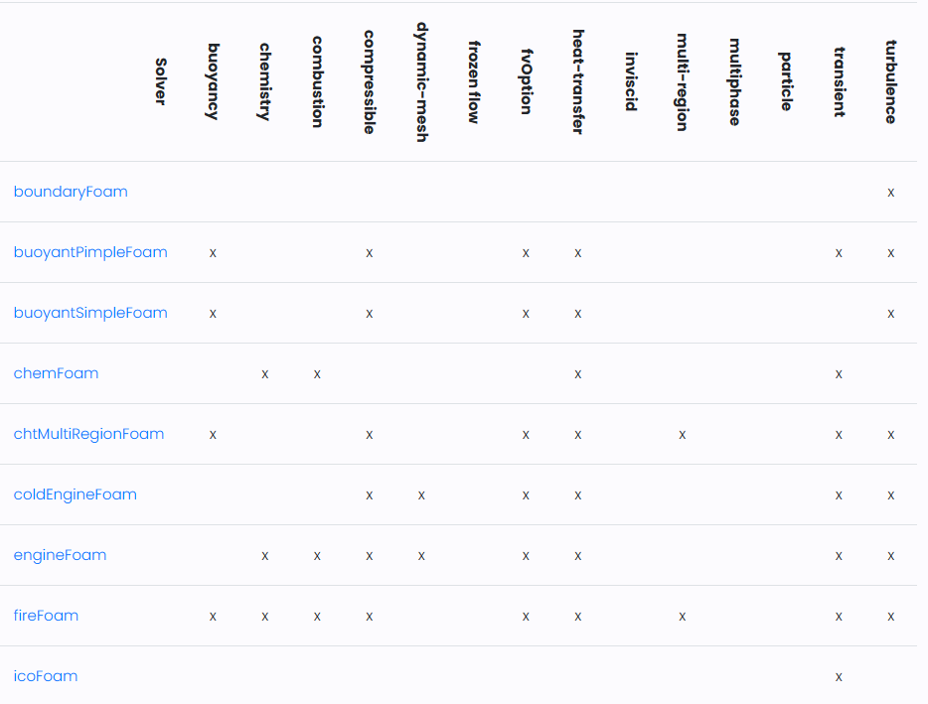
In the above capability matrix, it was seen that the “icoFOAM” solver was the best suited.
Locating the right Tutorial: The ‘directories’ in the tutorials are conveniently named after the corresponding solvers.
On opening the terminal, the “tut” shortcut was used to access the ‘tutorials’ directory.
On listing the objects in inside this directory, we find that the directory of interest was the ‘incompressible’ sub-directory.
It is in this directory that we find the tutorial corresponding to the ‘icoFOAM’ solver.
From the ‘icoFOAM’ directory, the ‘cavity’ directory was copied into the ‘run’ folder. This was to be our case-file. The modifications could be made and run here.
Geometry prep and Mesh generation:
It is required for the longer ‘x’ dimension to have 200 cells along its length and for the longer ‘y’ dimension to have 20.
From the freshly created directory in the ‘run’ folder, the ‘blockMeshDict’ script file was accessed by changing the present working directory to the ‘system’ sub-directory.
Here, the geometry was altered to suit the given problem.
For being able to conveniently create a finer mesh near the walls (using ‘simpleGrading’ to stretch the mesh that is away from the walls), we divided the geometry into five blocks.
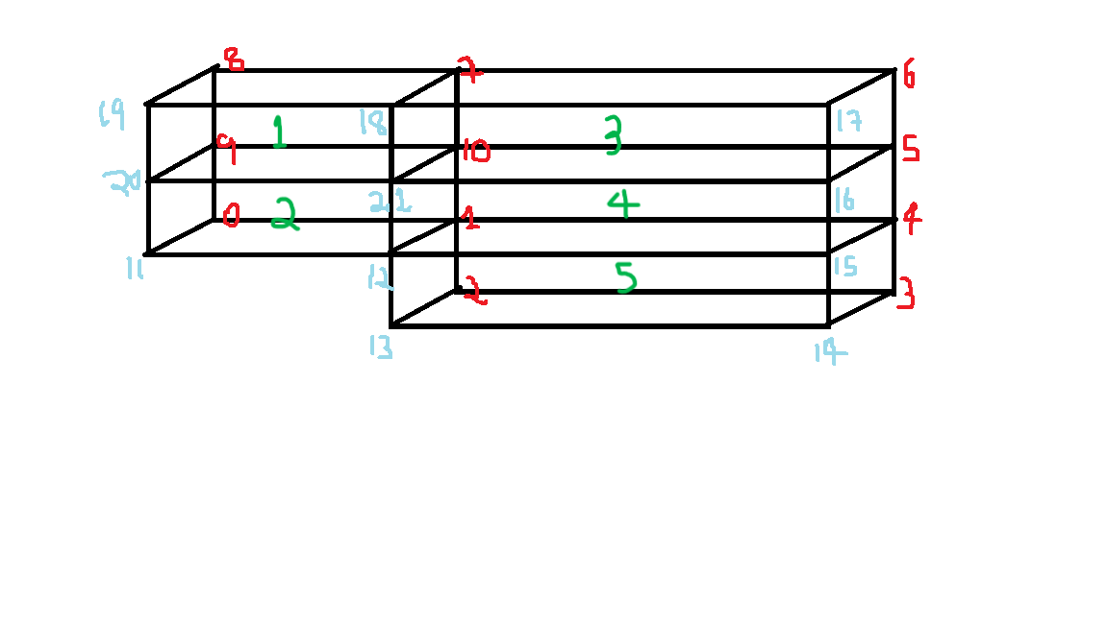

(Red vertices are on the backward face and the blue vertices on the forward face. The green markings label the blocks.)
This will enable the definition of the refined mesh needed in the second case.
The vertices are first defined in the ‘vertices’ section of the script file. As the code is in ‘C++’ the first vertex inputted (usually the origin) is given the index ‘0’. The indexing thus starts with ‘0’.
The blocks are then defined. The vertices for each block were entered in an order such that the local coordinate system of the blocks was in tune with the global coordinate system. The ‘hex’ stands for the hexahedral type mesh that the blocks were to be meshed with. The grading factor for the first case was to be ‘1’ in all directions for all the blocks, thus creating a uniform mesh.
The next section in the script file that was changed was the ‘boundaries’ section.
Here, the faces of the boundaries and their corresponding type were inputted accordingly.
These changes were then saved. The “blockMesh” command was then run for mesh generation.
The dimension of the generated mesh cells was ‘0.001m’. To keep the courant number at an acceptable value, it was decided to set the inlet velocity as ‘0.8m/s’ and the time-step size as ‘0.001s’
Inputting the time-step size:
The next script file to be edited was the ‘controlDict’ where the decided value of the time-step was inputted.
Defining the initial conditions:
The ‘0’ directory in the case-file contains all the script-files defining the initial conditions.
Velocity (‘U’)
In the ‘boundaryField’ section, the ‘movingWall’ boundary was renamed to the ‘inlet’. The type remained as ‘fixedValue’ and was changed to 0.8m/s.
Below this, a sub-section for ‘outlet’ was also created and was given the type ‘zeroGradient’.
The remaining parts of this section, remaining as it is, suited the set-up.

Kinematic Pressure (‘p’)
For, pressure and velocity conditions, if one is specified as a Neumann B.C, then the other must take on a Dirichlet B.C and vice-versa.
Similar changes to the script file were made as in the case for velocity.
In the ‘boundaryFields’, the ‘movingWall’ was similarly renamed and repurposed for defining the ‘inlet’. The type remained as ‘zeroGradient’, a Neumann B.C as the velocity B.C for here was subjected to a Dirichlet B.C. Similarly, for the outlet (for which a new sub-section was created), a ‘fixedValue’ of ‘uniform 0’ was inputted (being a Dirichlet condition).
For the ‘fixedWalls’, the type was inputted as ‘zeroGradient’ (a Neumann condition as the no slip condition was imposed for the velocity B.C here).
The ‘frontAndBack’ was given the type ‘empty’ as usual.

After making these changes, we run the simulation by typing ‘icoFoam’ into the terminal with the present working directory as the copied tutorial directory.
For case 2:
The grading factor is defined as the ratio of the cell dimension of the last cell in the specified direction to that of the first.
The only changes are made to the ‘blockMeshDict’ and the simulation time was upped to 1 second.
The grading factors were inputted such that the mesh was finer closer to the physical walls.
This ensured that the maximum physics were captures in these regions of importance without expending too much of the available computational resource.
Why ‘Grading Factor’ is important in meshing?
The grading factor is the ratio of the cell dimension of the last cell in a specified dimension to that of the first cell.
Thus, it ‘stretches’ the mesh in the way we require it, coarser towards a direction and finer in the direction opposite towards it and vice-versa.
Thus, this ‘stretching’ of the mesh lets us keep the mesh finer in places of interest (like near the walls in this problem) while keeping the total number of computational cells as low as possible. Thus, it lets us capture more accurate results without taking on too much of the added computational cost.
Thus, in short, such an altered mesh give more accurate results while being computationally efficient.
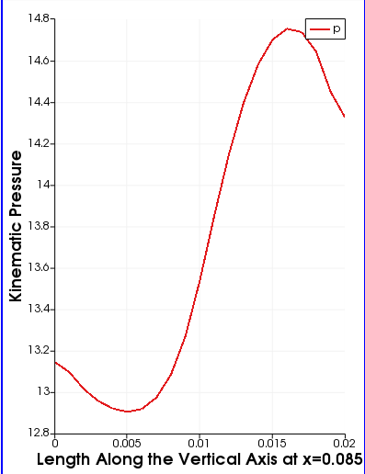
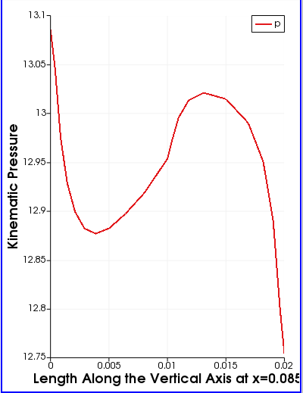
(Line plot for kinematic pressure magnitude at 0.085m from the inlet)

